Report about best devices in PC, best operating system and suitable programming languages.
System Name: Medical Appointment Booking System
- Best Devices
PC Core I5+ 8 Ram to run project smoothly
- Best Operating System
Windows 10/11 because Wpf & Sql Server made to windows

- Suitable Programming Languages
C# (.Net) because it support Entity Frame Work and easy to connect Sql Server integration

- Suitable Applications
WPF

Design of an integrated system (Class diagram)

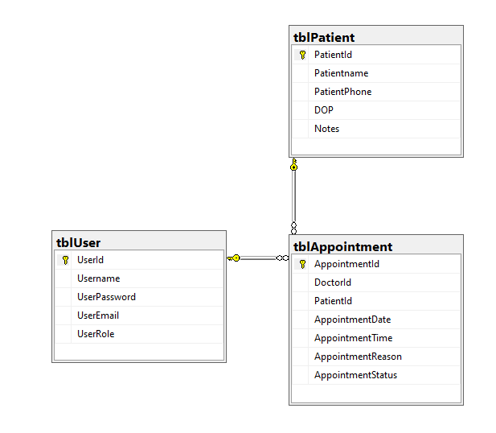

Testing
Test case ID | Test case description | Test Steps | Test Data | Expected Result | Actual Result | Pass/Fail
1 | Test Login Page  Enter Valid username and password to Doctor Page | Enter username  Enter password  Click Login | Username= DrAhmed  Password= 1234 | Go to Daily Schedule View Page | Go to Daily Schedule View Page | Pass
2 | Test Login Page  Enter Valid username and incorrect password to Doctor Page | Enter username  Enter password  Click Login | Username= DrAhmed  Password= 4321 | Invalid username and password! | Invalid username and password! | Pass
3 | Test Login Page  Enter null username and password to Doctor Page | Enter username  Enter password  Click Login | Username= null  Password= null | Please Fill username and password! | Please Fill username and password! | Pass
4 | Test Login Page Enter Correct Password and username to Patient | Enter username  Enter password  Click Login | Username= Adham  Password= 1234 | Go to Patient Page | Please Fill username and password! | Fail
5 | Test Login Page  Enter Valid username and password to Doctor Page with click enter without mouse | Enter username  Enter password  Click Enter | Username= DrAhmed  Password= 1234 | Go to Daily Schedule View Page | Go to Daily Schedule View Page | Pass
6 | Test Login Page  Enter Valid username and password to Doctor Page | Enter username  Enter password  Click Login | Username= Mona  Password= 1234 | Appointment Scheduling Page | Appointment Scheduling Page | Pass

